Q6(b): (Second M mark)

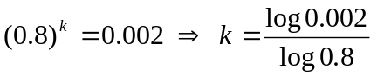 M0 (Insufficient to 'show')
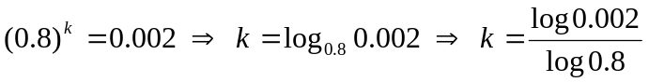 M1 (Change of base rule implied)

(Similarly with the inequality signs in the above statements.)

Q7(d): Alternative method

Adding area of segment to area of triangle BCD

Correct method for area of triangle BCD M1

Follow through, if necessary, from any values found previously (e.g. CD, BD) A1ft
(The correct answer, of course, is 8.78…, the same as triangle ABD!)

Adding their segment (found from correct formula) to their triangle BCD M1

awrt 10.8 A1

(Note there are still no marks for only the segment)

